A2622-Eur-England-Lincolnshire-Puritan Bible Coffer-English Oak and Wrought Iron-c 1625

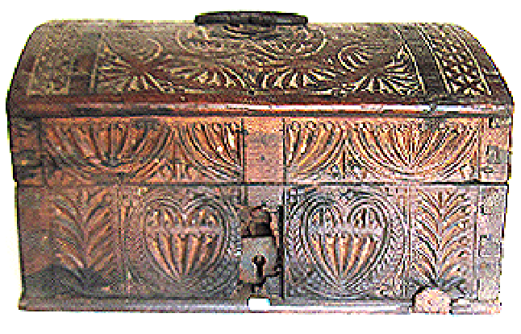 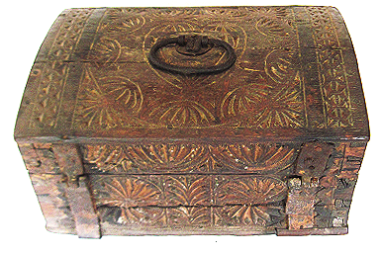

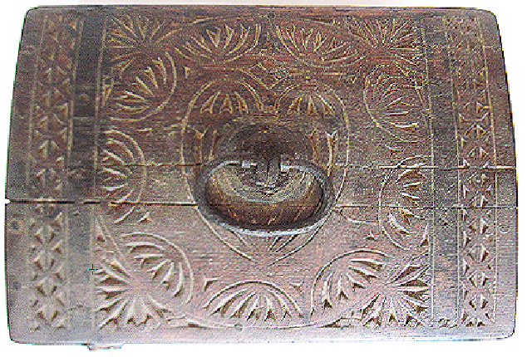

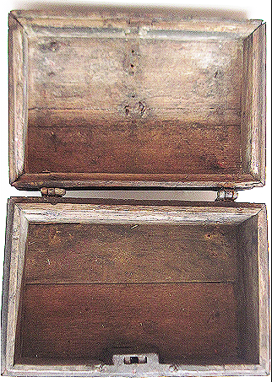

**Figs. 1-4.** Eur-England-Lincolnshire-Puritan Bible Coffer-English Oak and Wrought Iron-c 1625

**Case no.: Early American**

**Accession Number: A2622**

**Formal Label:** Eur-England-Lincolnshire-Puritan Bible Coffer-English Oak and Wrought Iron-c ‎1603–1625

**Display Description:**

This is a stunning English Jacobean (‎1603–1625) carved oak Bible coffer of the early 17th century that was Puritan-inspired. The lid and all sides are beautifully carved with a series of rosettes, menorahs and hearts. Perhaps it was made as a wedding gift. All wooden parts and iron fittings, including hinges and the lock, are original.

**LC Classification: BX9333,** BX7230

**Date or Time Horizon: c** 1603–1625

**Geographical Area:** East Anglia, perhaps Boston, Lincolnshire.

**Map:**

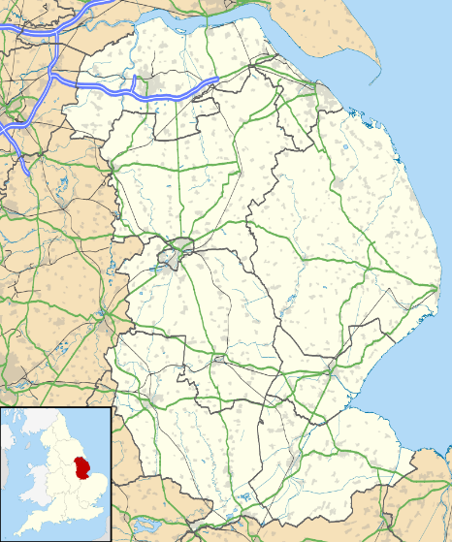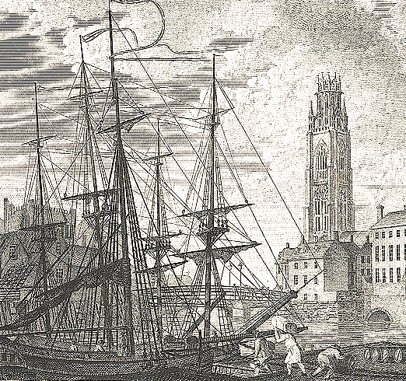

Fig. 5. Location of Boston, Lincolnshire, By Anonymous - "Boston" in the Encyclopædia Britannica, 9th ed., Vol. IV, p. 72., Public Domain, <https://commons.wikimedia.org/w/index.php?curid=46484780>

Fig. 6. The cathedral church of St Botoph’s, Boston, Lincolnshire, with its tall, 272 foot spire, where Anne Hutchinson was a parishioner of Rev. John Cotton, until he left for Boston, Massachusetts, in 1633 and she followed him a year later. Boston was a port city. Note the ships in the docks in the foreground. Engraved by J. Walker after a picture by W. Brand, published in *The Copper Plate Magazine*, 1795.

**GPS coordinates:** [52.974°N 0.0214°W](https://tools.wmflabs.org/geohack/geohack.php?pagename=Boston,_Lincolnshire&params=52.974_N_0.0214_W_region:GB_type:city(35124))

**Cultural Affiliation:** English Puritanism

**Media:** English oak and wrought iron

**Dimensions:** H 7 in, L 12.75 in, W 9.25 in

**Weight:** 6 lb 14.75 oz, 13 kg 125 gm

**Condition:** original

**Provenance:** brought to Massachusetts Bay c 1630’s, then in the Brehaut Family of Danvers, MA, until 1986.

**Discussion:**

The Rev. John Cotton was the parish minister of Boston, Lincolnshire. He was a graduate of Cambridge University, and, he became the teaching minister of the first Church in Boston, Massachusetts in 1633. One of his parishioners from old Boston was Mistress Anne Hutchinson, a midwife, who arrived in Boston in 1634 with eleven of her children.

Almost immediately Anne Hutchinson began to hold Thursday night prophesyings or interpretations of recent sermons given by Massachusetts Bay ministers. Her rôle in accusing the local ministers (except for John Cotton) of preaching a "covenant of works" rather than a "covenant of grace" was based on the claim that she had direct revelations about the meaning of certain Biblical texts, and, therefore, she did not need the approbation of the ecclesiastical hierarchy. This was the main reason she was ostracized by the ministers of the Bay Colony and then convicted of treason against the colony by a church court in 1637.

Meanwhile, Anne Hutchinson’s husband and other shop keepers also ran amuck of the law by charging higher prices for their dry goods (especially hand-wrought carpentry nails) based on supply and demand economics. These higher prices were imposed without asking permission from Governor Winthrop and the legislature. These shopkeepers, as well, were labeled “Antinomians” (in this case, businessmen against the law) for this infraction against the political hierarchy.

Consequently, both groups of Antinomians, ecclesiastical and political, were banned from the Colony. In their flight to the Dutch Colony of New York, which offered them sanctuary, they were murdered by Pequod Indians who thought that their entourage was a returning group of Colonial militia. Earlier, in 1636, Capt. Underhill had been sent to the Pequod stronghold in the marshes of southern Connecticut and had killed many Pequods on orders of Gov. John Winthrop. Perhaps Underhill’s slaughter was to foment the Pequods against the fleeing Antinomians so that word of their banishment would not reach England.

This Bible coffer, therefore, was not owned by one of the murdered Antinomians. It was preserved for posterity by one of those colonists who had accepted the strict Congregationalism of John Cotton in which it was decreed that one must not interpret the Bible without the approbation of her or his minister.

**References:**

Adams, Charles Francis, ed. *Antinomianism in the colony of Massachusetts Bay, 1636-1638.* Boston: Printed for the Prince Society, v. 21. Boston: Prince Society.

Battis, Emery John. 1962. *Saints and sectaries: Anne Hutchinson and the Antinomian controversy in the Massachusetts Bay Colony.* Chapel Hill, NC: Published for the Institute of Early American History and Culture at Williamsburg, Va., by the University of North Carolina Press.

### Cotton, John. 1968. [John Cotton on the churches of New England](https://hollis.harvard.edu/primo-explore/fulldisplay?docid=01HVD_ALMA211765517790003941&context=L&vid=HVD2&lang=en_US&search_scope=default_scope&adaptor=Local%20Search%20Engine&tab=books&query=lsr02,contains,386587). Edited by Larzer Ziff. The John Harvard

### Williams, Selma R. 1981. Divine rebel: the life of Anne Marbury Hutchinson. New York: Holt, and Rinehart and Winston.